**EXP 6:- Implement program to apply moving average smoothing for data preparation and time series forecasting**

**AIM:**

To apply moving average smoothing on the daily confirmed COVID-19 cases over time

**ALGORITHM:**

**Step 1: Load the Dataset**

* Import the necessary libraries (pandas, matplotlib, ARIMA).
* Load the dataset from a CSV file into a pandas DataFrame.

**Step 2: Clean and Preprocess the Data**

* Clean the column names by stripping any leading or trailing spaces.
* Convert the Date column to a datetime format.
* Set the Date column as the index of the DataFrame for time series analysis.
* Sort the data by date to ensure chronological order.

**Step 3: Aggregate Global Daily Confirmed Cases**

* Group the data by Date and sum the confirmed cases for each day.

**Step 4: Create Daily New Cases**

* Calculate the daily new cases by finding the difference in confirmed cases between consecutive days.
* Remove any rows with missing values (such as the first row).

**Step 5: Add Moving Averages (SMA and EMA)**

* Calculate a 5-day Simple Moving Average (SMA) for the daily new cases.
* Calculate a 5-day Exponential Moving Average (EMA) for the daily new cases.

**Step 6: Fit ARIMA Model for Forecasting**

* Fit an ARIMA model to the daily new cases with the appropriate parameters (e.g., p=1, d=1, q=1).
* Use the model to forecast the next 5 days of daily new cases.

**Step 7: Prepare Forecast Data**

* Create a DataFrame to store the forecasted daily new cases and their corresponding dates.
* Combine the actual daily cases and the forecasted values into a single DataFrame.

**Step 8: Plot the Data**

* Plot the original daily new cases, the 5-day SMA, the 5-day EMA, and the forecasted daily cases on a single graph.
* Customize the plot by adding labels, a title, and a legend.

**Step 9: Save the Processed Data**

* Save the combined dataset (including both actual and forecasted daily new cases) to a new CSV file.

**PROGRAM:**

**OUTPUT:**

import pandas as pd

import matplotlib.pyplot as plt

from statsmodels.tsa.arima.model import ARIMA

file_path = "/time-series-19-covid-combined.csv"

df = pd.read_csv(file_path)

df.columns = df.columns.str.strip()

df["Date"] = pd.to_datetime(df["Date"], format="%Y-%m-%d")

df.set_index("Date", inplace=True)

df.sort_index(inplace=True)

daily_df = df.groupby(df.index).sum()

daily_df["daily_cases"] = daily_df["Confirmed"].diff().dropna()

daily_df = daily_df.dropna(subset=["daily_cases"])

daily_df["SMA_5"] = daily_df["daily_cases"].rolling(window=5).mean()

daily_df["EMA_5"] = daily_df["daily_cases"].ewm(span=5, adjust=False).mean()

model = ARIMA(daily_df["daily_cases"], order=(1, 1, 1))

model_fit = model.fit()

forecast = model_fit.forecast(steps=5)

future_dates = pd.date_range(start=daily_df.index.max() + pd.Timedelta(days=1), periods=5)

forecast_df = pd.DataFrame({"Date": future_dates, "Forecasted_daily_cases": forecast})

forecast_df.set_index("Date", inplace=True)

combined_df = pd.concat([daily_df, forecast_df], axis=0)

plt.figure(figsize=(12, 6))

plt.plot(daily_df.index, daily_df["daily_cases"], label="Original Daily Cases", linestyle='dotted', marker='o', alpha=0.6)

plt.plot(daily_df.index, daily_df["SMA_5"], label="5-Day SMA", color='red')

plt.plot(daily_df.index, daily_df["EMA_5"], label="5-Day EMA", color='green')

plt.plot(forecast_df.index, forecast_df["Forecasted_daily_cases"], label="Forecasted Daily Cases", color="blue", marker="x", linestyle="--")

plt.legend()

plt.title("COVID-19 Daily Cases: Smoothing and Forecasting")

plt.xlabel("Date")

plt.ylabel("Daily New Cases")

plt.tight_layout()

plt.show()

output_path = "/mnt/data/covid_smoothed_forecast.csv"

combined_df.to_csv(output_path)

print(f"✅ Smoothed and forecasted data saved to: {output_path}")

**OUTPUT:**

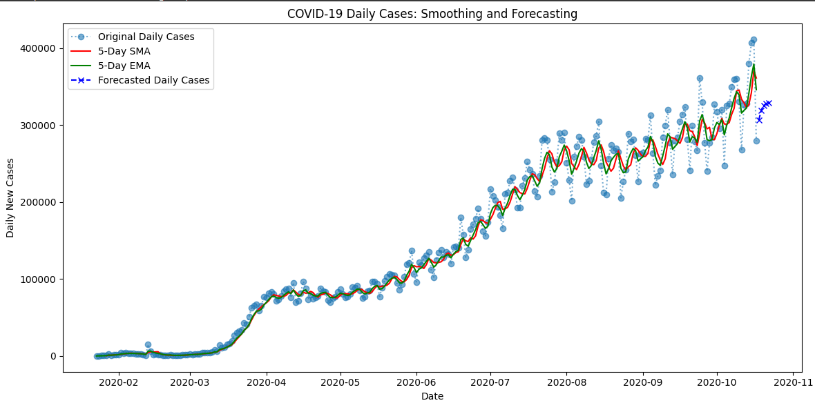

**RESULT:**

Moving average smoothing effectively reduces fluctuations in the **RANK** column over **YEAR**, highlighting overall trends. The **SMA** provides a stable long-term trend, while the **EMA** quickly adapts to recent changes, making trend analysis and forecasting more reliable.